PRACTICAL 5:
Producer_consumer.c
#include <stdio.h>
#include <stdlib.h>
#include <unistd.h>
#include <string.h>
#include <sys/wait.h>
#include <time.h>

#define NUM_MESSAGES 1000
#define MESSAGE_SIZE 100

int main()
{
int fd[2];
pid_t pid;
char message[MESSAGE_SIZE];

clock_t start, end;
double time_taken;

if (pipe(fd) == -1)
{
perror("pipe failed");
return 1;
}

start = clock();

pid = fork();

if (pid < 0)
{
perror("fork failed");
return 1;
}

if (pid == 0)
{
// Child process = Consumer
close(fd[1]);

for (int i = 0; i < NUM_MESSAGES; i++)
{
read(fd[0], message, MESSAGE_SIZE);
}

close(fd[0]);

printf("Child: Consumed %d messages\n", NUM_MESSAGES);
}
else
{
// Parent process = Producer
close(fd[0]);

for (int i = 0; i < NUM_MESSAGES; i++)
{
snprintf(message, MESSAGE_SIZE,
"Message %d from parent", i + 1);

write(fd[1], message, MESSAGE_SIZE);
}

close(fd[1]);

wait(NULL);

end = clock();

time_taken = ((double)(end - start)) / CLOCKS_PER_SEC;

printf("Parent: Produced %d messages\n", NUM_MESSAGES);
printf("Communication time: %f seconds\n", time_taken);

if (time_taken > 0)
{
printf("Efficiency: %.2f messages/second\n",
NUM_MESSAGES / time_taken);
}
}
return 0;
}

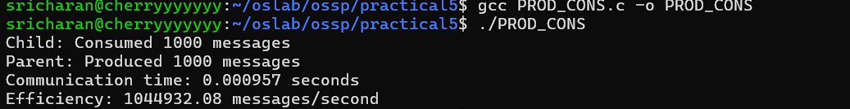

Grep.c
#include <stdio.h>
#include <stdlib.h>
#include <unistd.h>
#include <sys/wait.h>

int main()
{
int fd[2];
pid_t pid1, pid2;

// Create pipe
if (pipe(fd) == -1)
{
perror("pipe failed");
return 1;
}

// First child for: ls -l
pid1 = fork();

if (pid1 < 0)
{
perror("fork failed");
return 1;
}

if (pid1 == 0)
{
// Redirect standard output to pipe
dup2(fd[1], STDOUT_FILENO);

close(fd[0]);
close(fd[1]);

// Execute ls -l
execlp("ls", "ls", "-l", NULL);

perror("execlp failed");
exit(1);
}

// Second child for: grep ".c"
pid2 = fork();

if (pid2 < 0)
{
perror("fork failed");
return 1;
}

if (pid2 == 0)
{
// Redirect standard input from pipe
dup2(fd[0], STDIN_FILENO);

close(fd[0]);
close(fd[1]);

// Execute grep ".c"
execlp("grep", "grep", ".c", NULL);

perror("execlp failed");
exit(1);
}

// Parent closes both pipe ends
close(fd[0]);
close(fd[1]);

// Wait for both children
wait(NULL);
wait(NULL);

return 0;
}
